**AWS CLOUD COMPUTING**

**Practical no.8**

**AIM:** Create SQL server Using RDS & Also Demonstrate DynamoDB**.**

## 

## **Step 1. Navigate to the RDS Console**

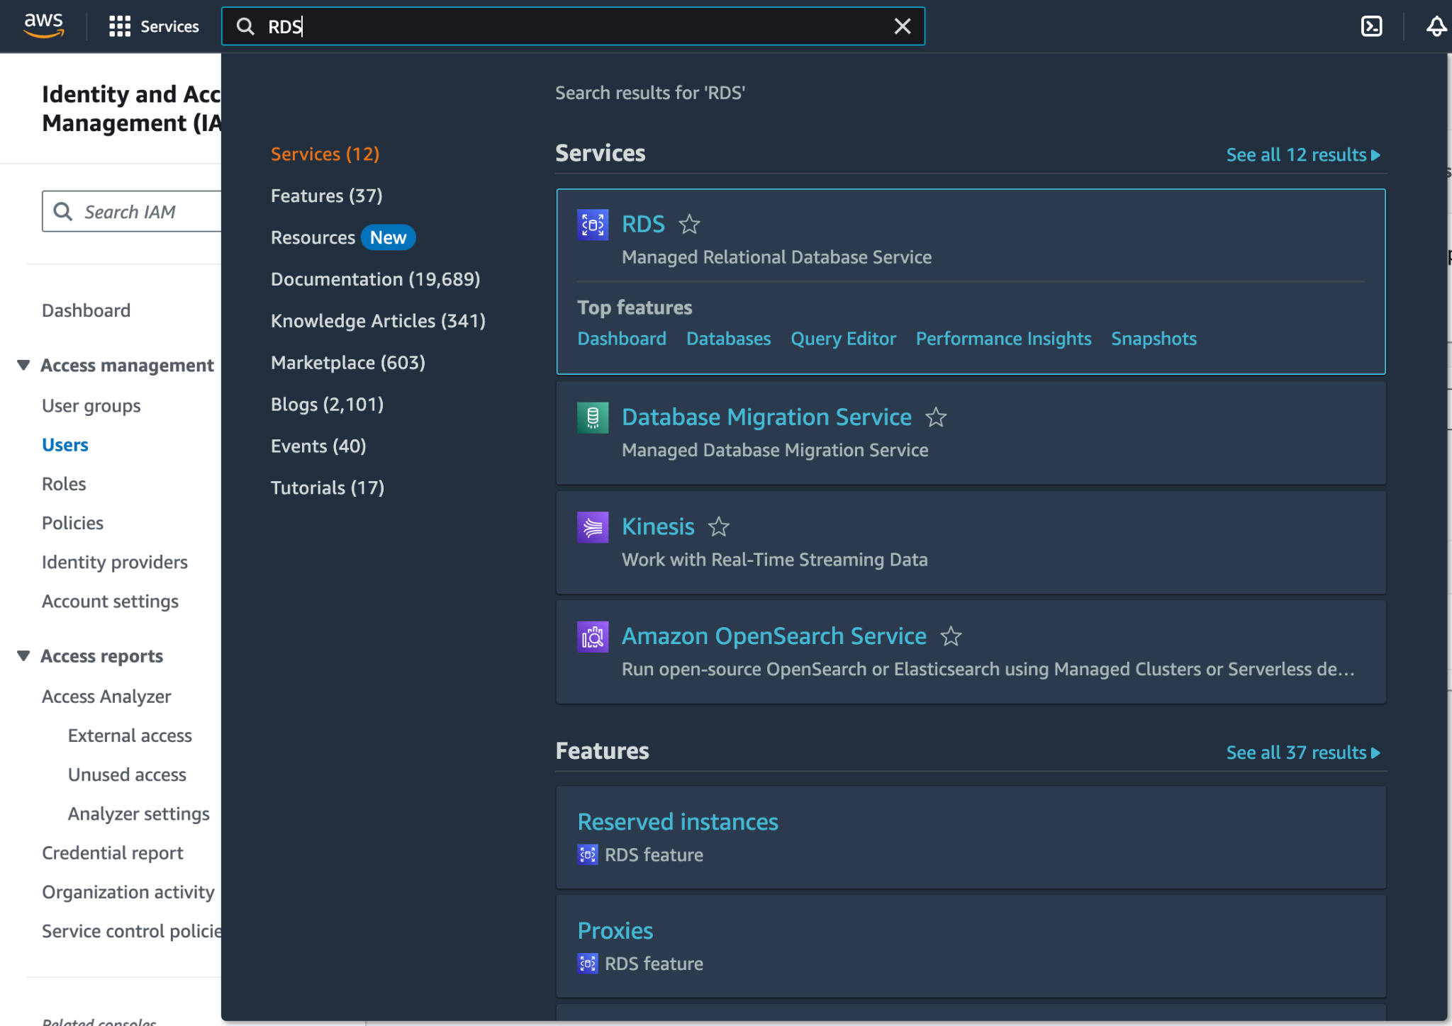

## 

## 

## 

## 

## 

## **Step 2. Click on create database and select microsoft SQL server and also select templates as free tier to avoid unnecessary billing. Then add a custom password to secure the account. Finally click on create database.**

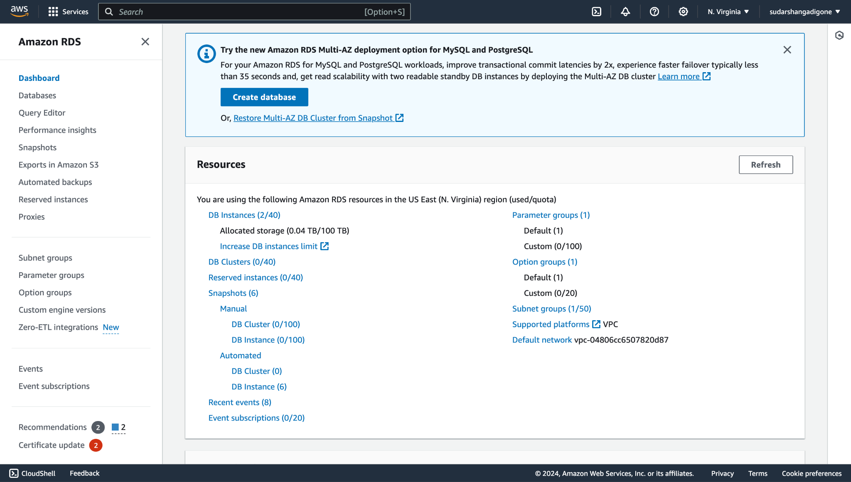

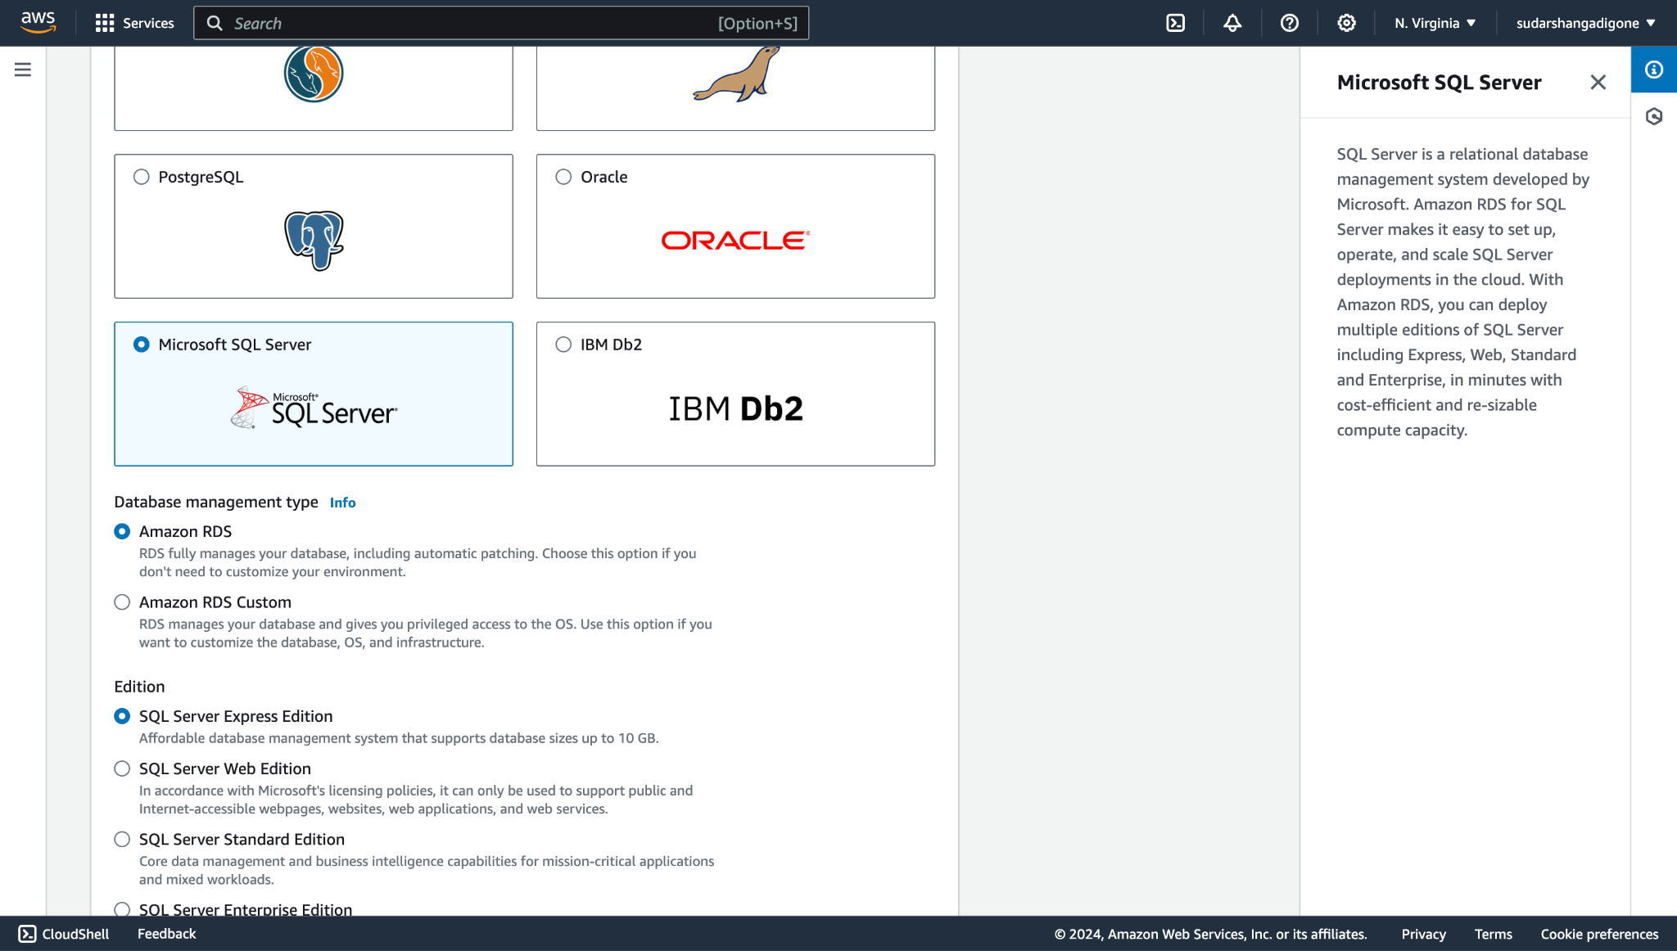

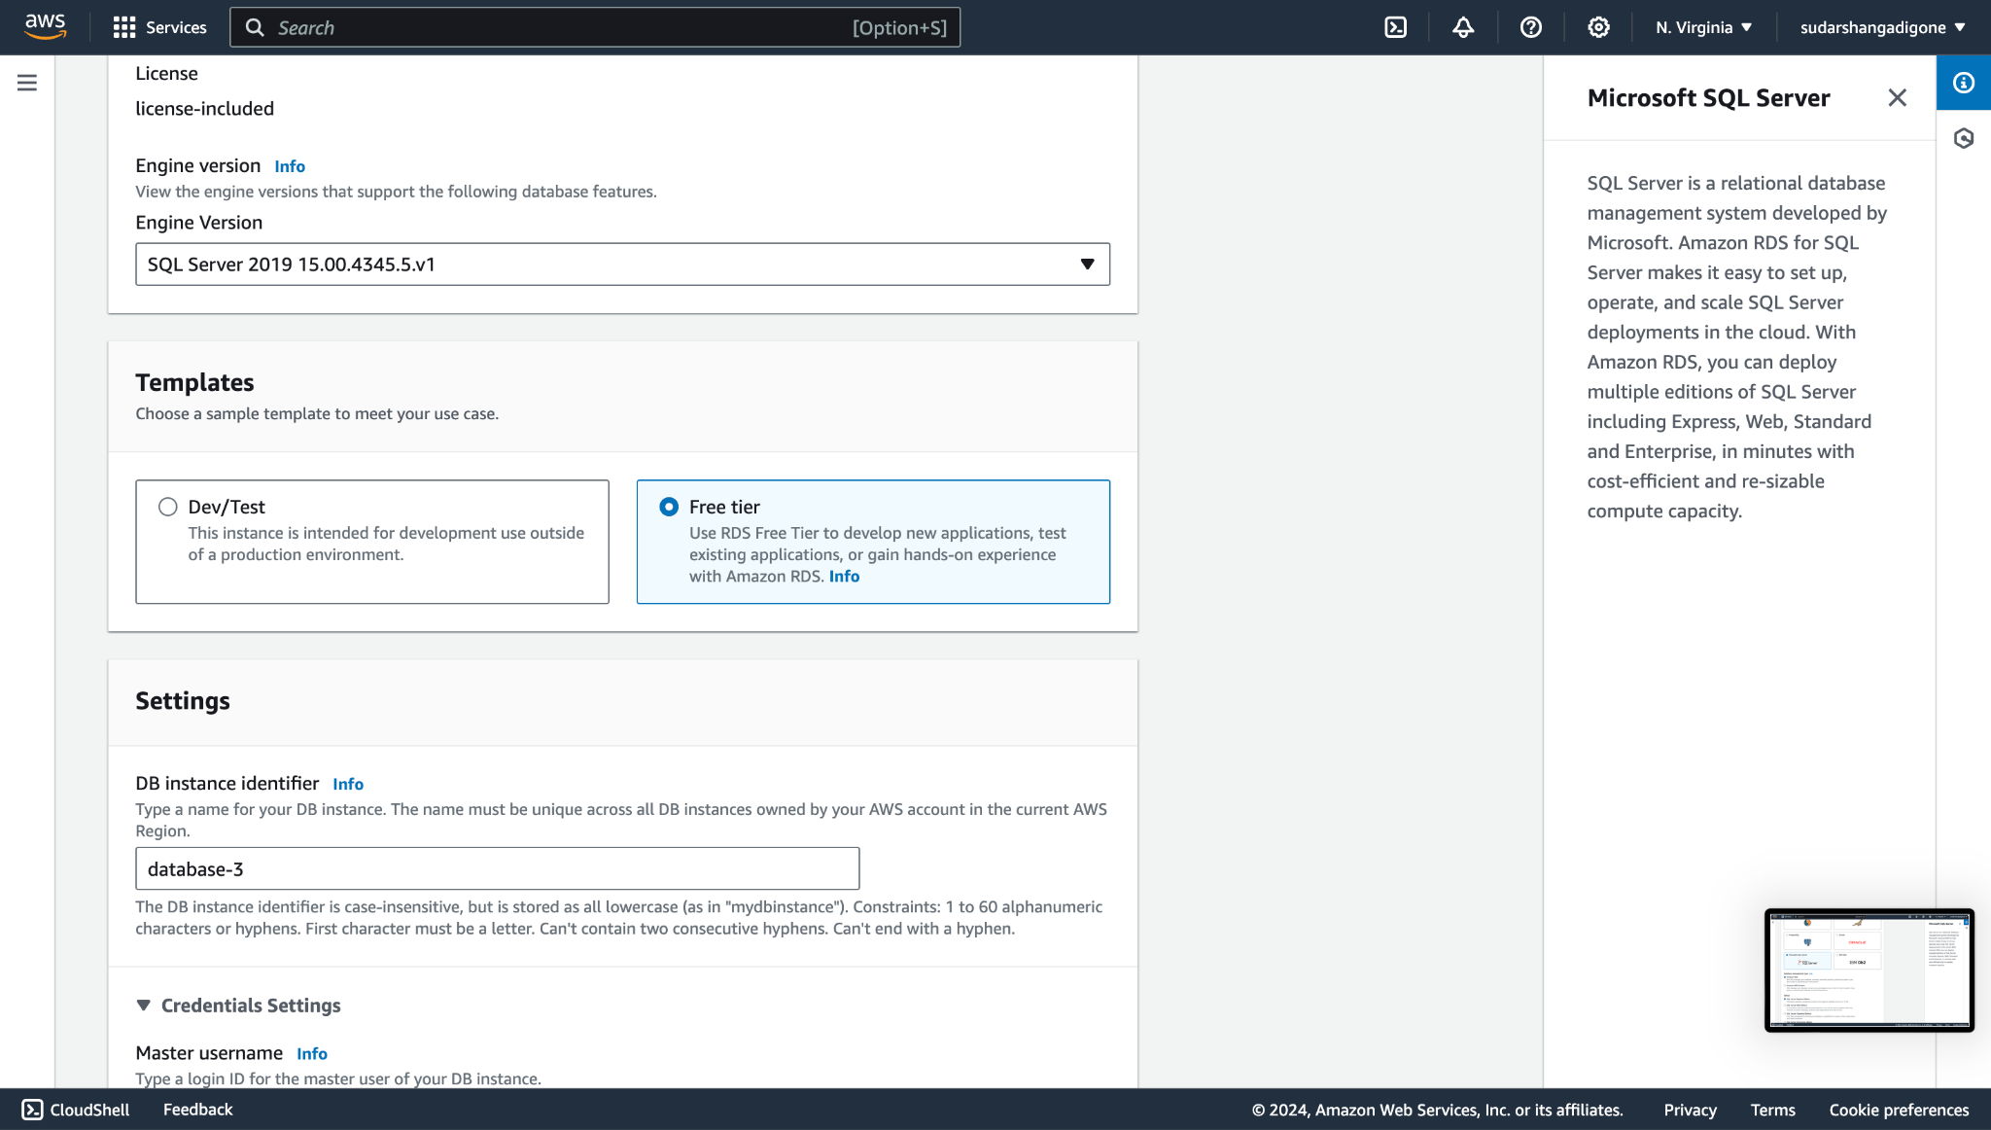

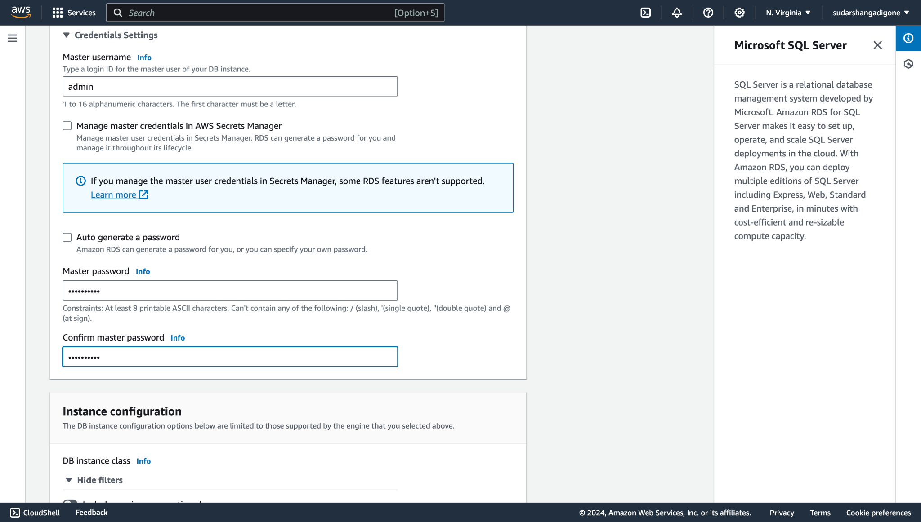

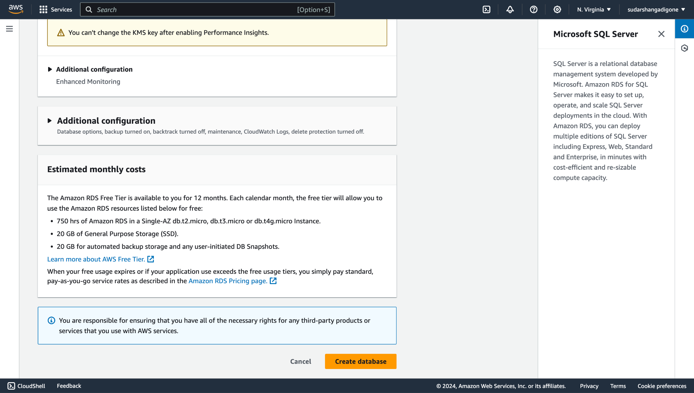

## **Step 3. Login into SQL server by username as admin and using the custom password which you have generated in the previous step.**

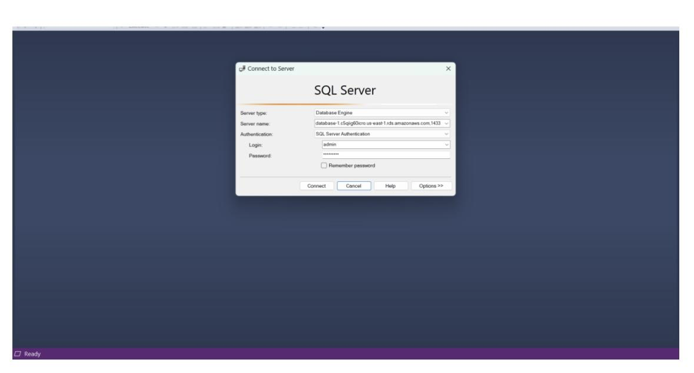

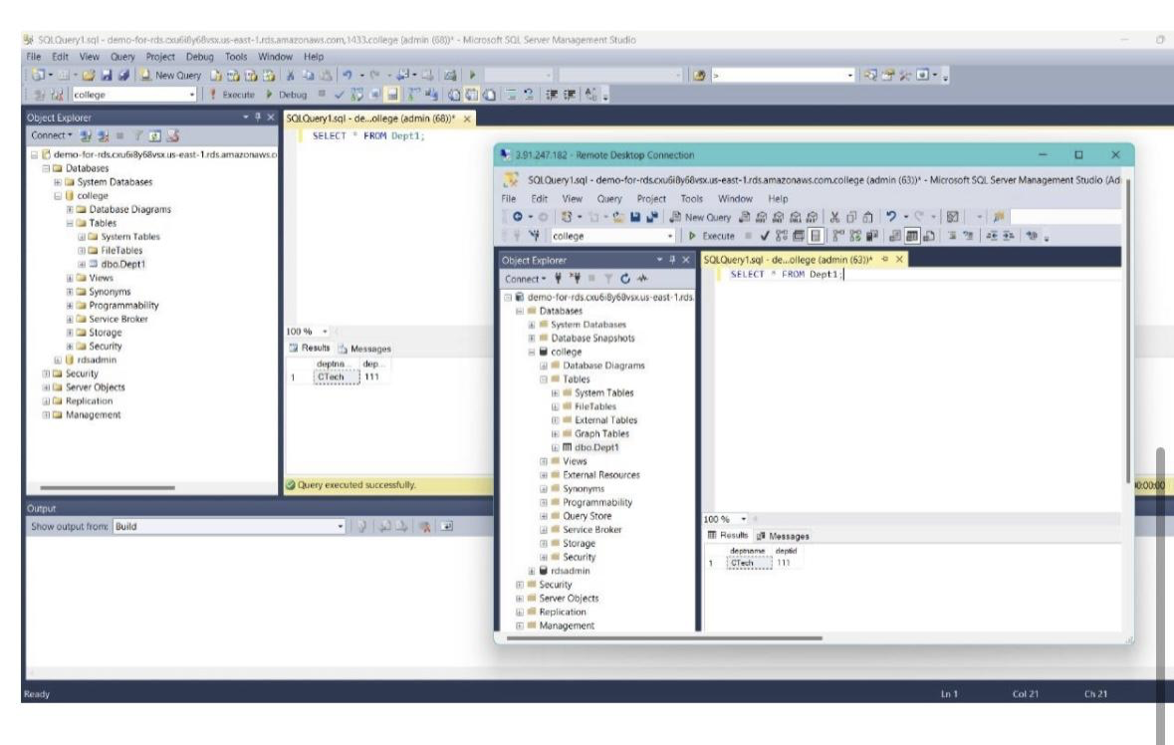

**CONCLUSION:**

Thus we have successfully created a SQL server Using RDS & Also demonstrated DynamoDB.